Andy Rowell
February 19, 2007
Program and Curriculum Development

How to Use a Completely Free Tool: Biblegateway.com
Note: The Best Bible Study Tools on the Web at http://www.andyrowell.net/andy_rowell/2006/02/basic_bible_stu.html

- Go to http://www.biblegateway.com/
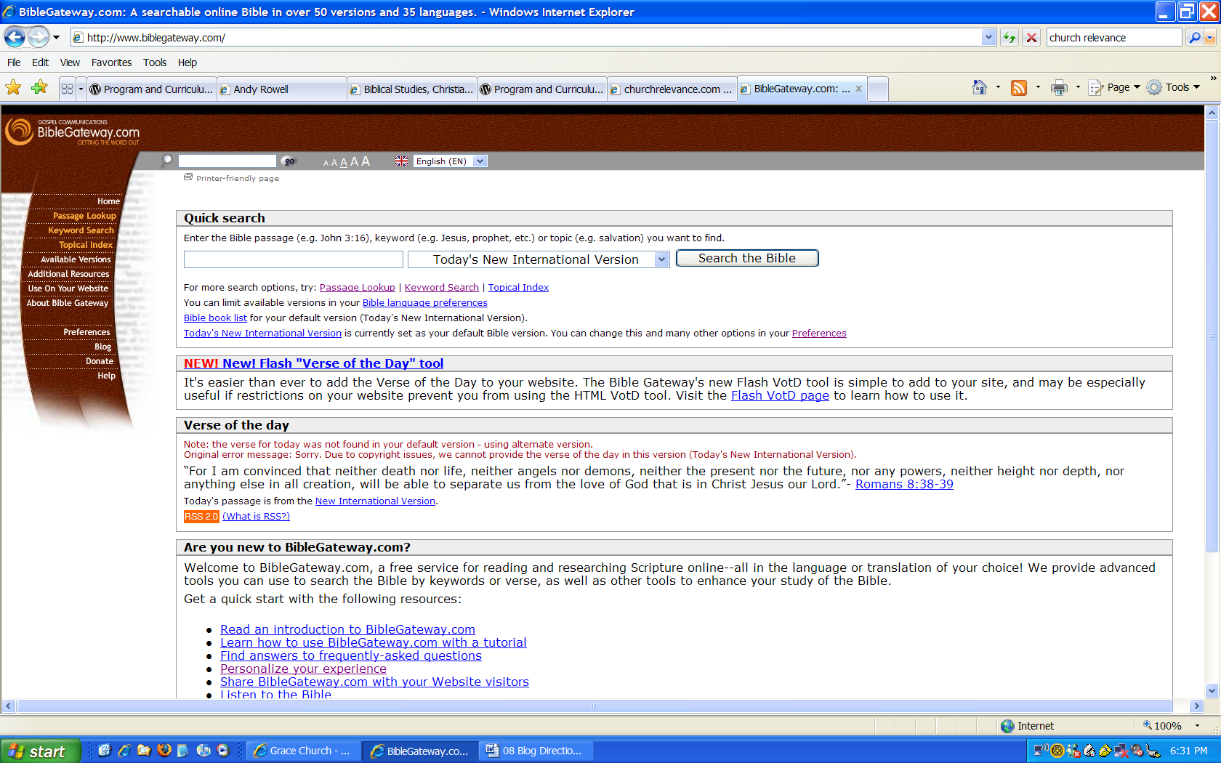
- You can search for a word or a chapter and verse on the home page.
- You can also change which version you are searching.
- Now let’s go to Passage Lookup.
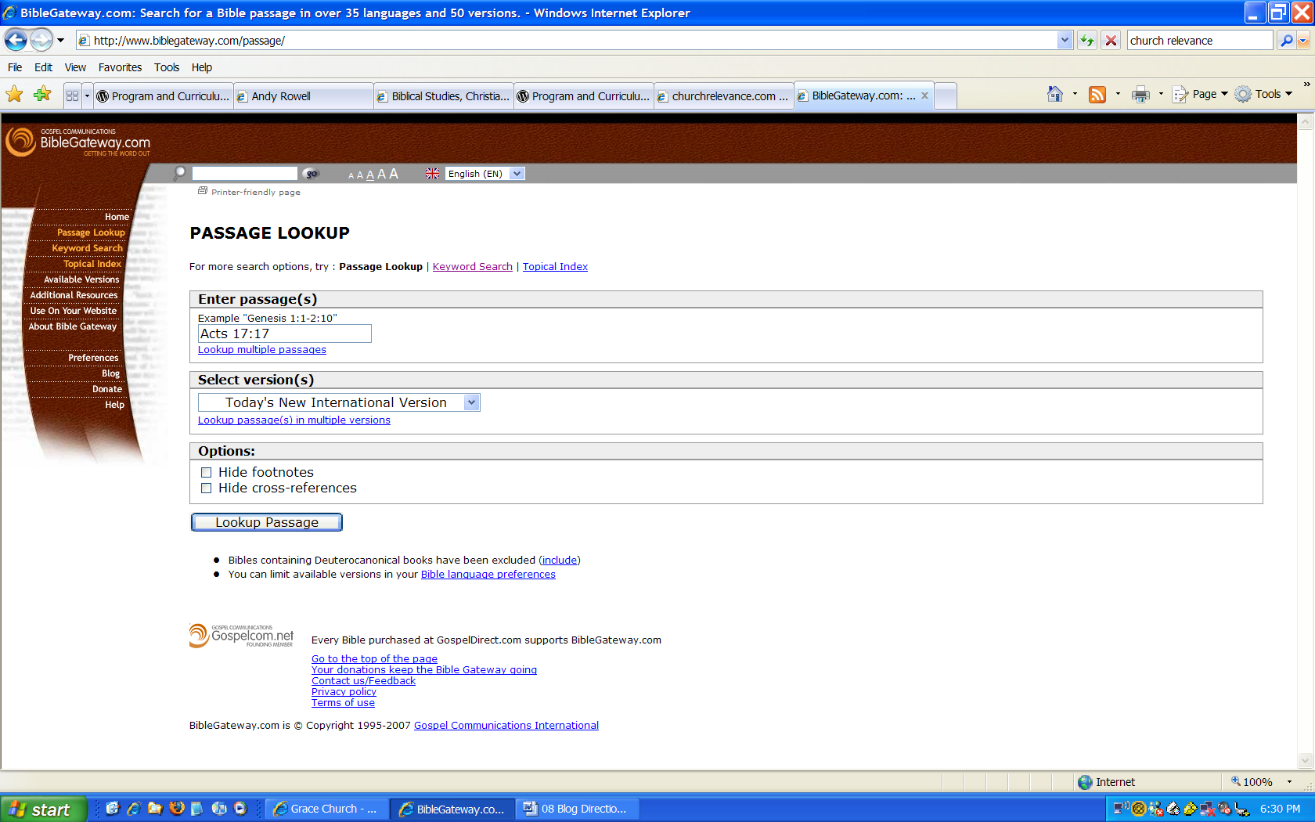

- You can look up lots of different passages in lots of different versions at the same time.

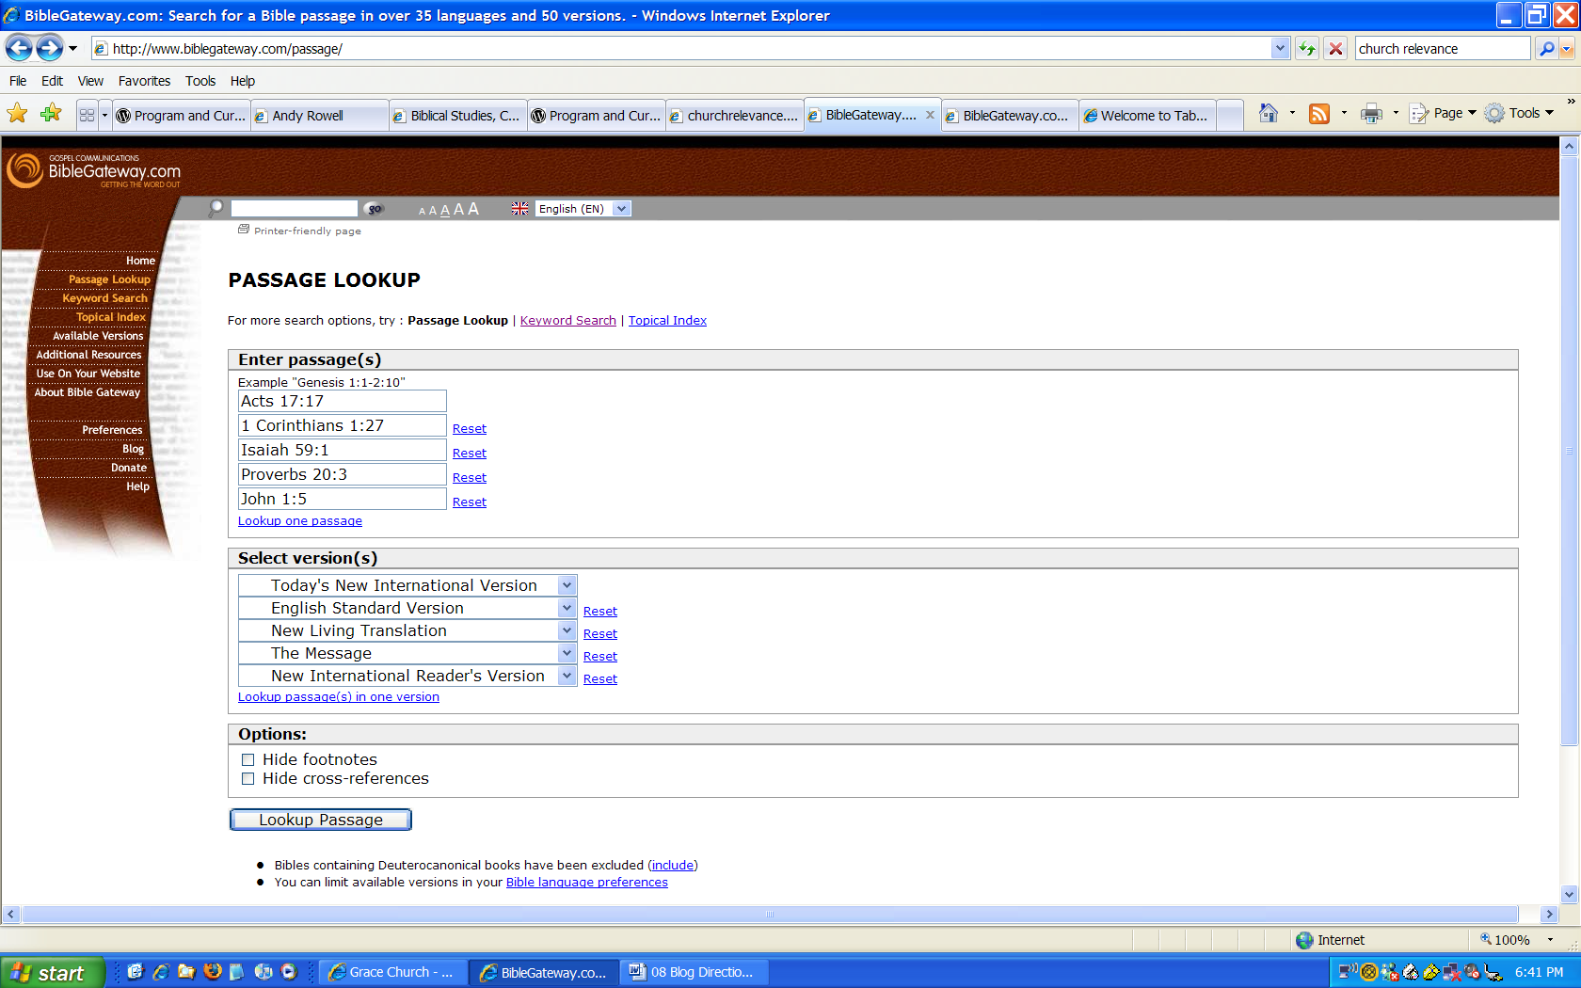

- You can also go to Keyword Search and look up different words.

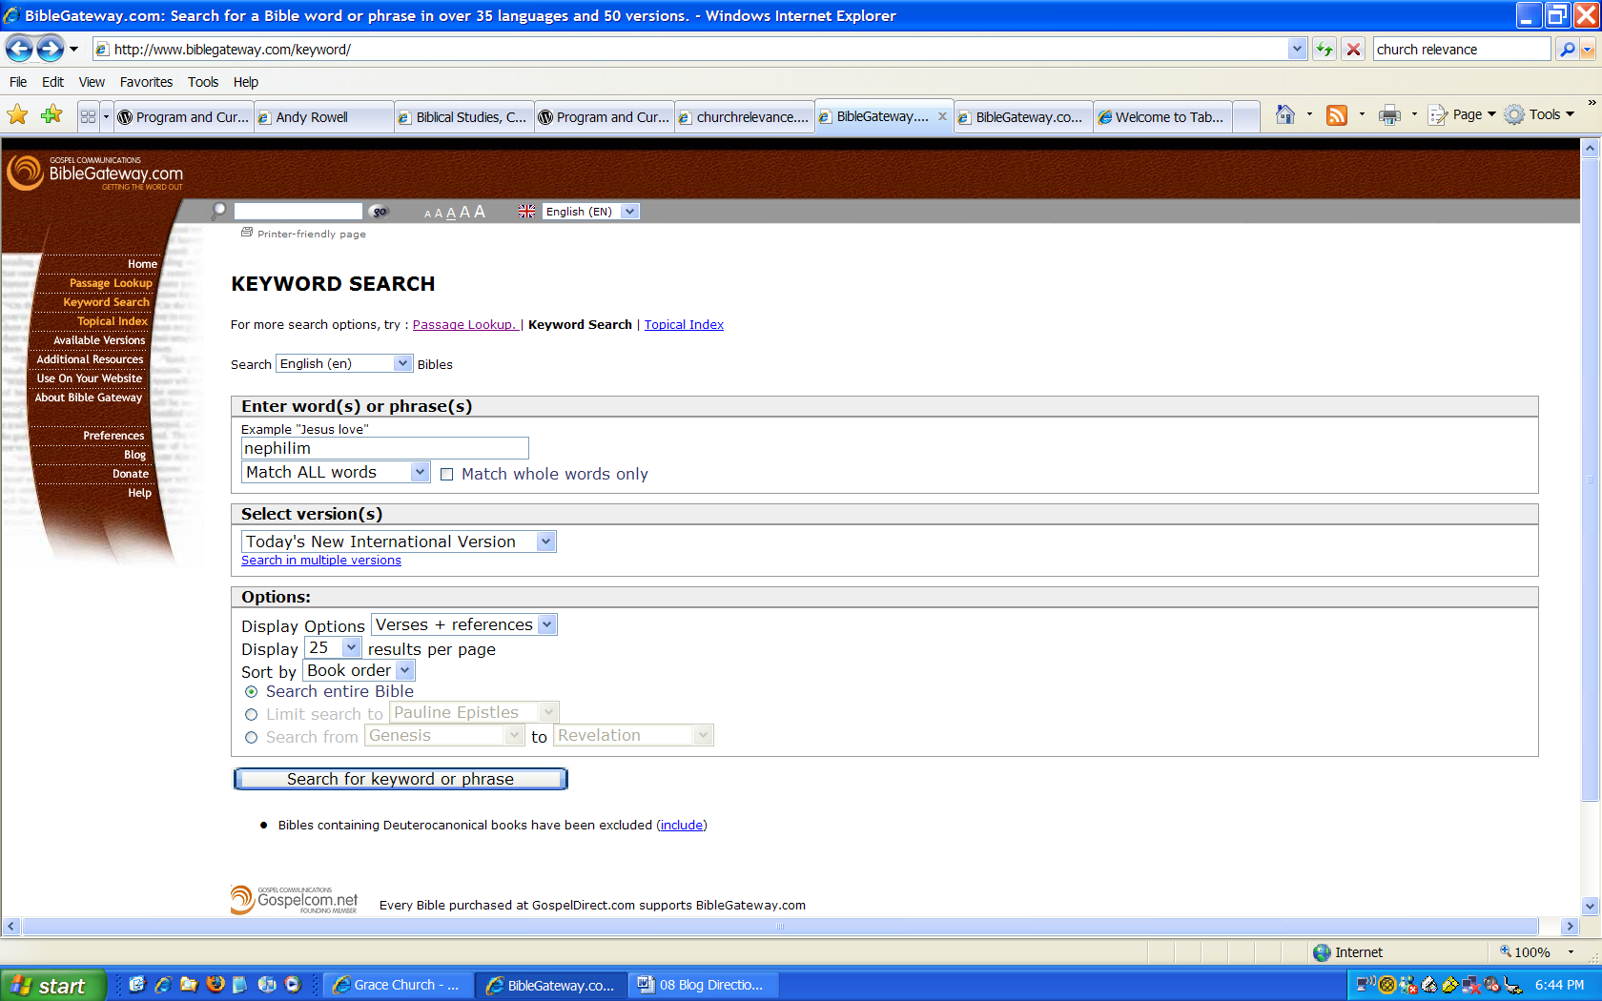
- Look up a verse in the TNIV and then click “Listen to this passage.” You can listen to it in Real Player. (Sorry you can’t download it for listen to more than a chapter at a time).
- You can change your default bible in Preferences. Choose TNIV! ☺

